JERIN. M.J 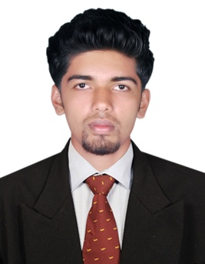
207/B, Shree Girnar Tower CHS Ltd, Saibaba Nagar, Mira Road East, Thane-401107 Land Line-022-28118313, Mob;-9605169535 E- mail: jerinedaparambil@gmail.com

OBJECTIVE
I want to enhance my knowledge by working in a reputed organization like yours. By this I want to grow professionally, personally and contribute to the organizational growth.

EDUCATIONAL QUALIFICATION

 | Degree | Name of the  Institution | University/ Board | Year of passing | Percentage  %
1 | B.E (Mechanical Engineering) | A.S.L Pauls college of Engineering and Technology, Coimbatore.. | Anna  University, Chennai | 2016 | 70% (up to 7th sem)
2 | H.S.C. | Govt. higher secondary school , Agali | State Board | 2012 | 63%
3 | S.S.L.C. | St. Peters CHS Kookampalayam | State Board | 2010 | 66%

FIELD OF INTEREST
- Production/Maintenace/Service
- Quality checking
- Product designing

SOFTWARE SKILLS
- Know basics about, AutoCAD, Pro.e, MS office , CLanguages, Photoshop .

ACHEVEMENTS
- Attend the workshop “CHALLENGES ON MAJOR ACCIDENTAL HAZARDS AND COTROL IN ENGINEERING INDUSTRY” Conducted by our campus.

PROGRAMMES ORGANISED

- Organised the Technical Quiz for “MACHINOSUS’15” in ASL Pauls College of Engineering
and Technology, Coimbatore.

HOBBIES
- Listening Musics
- Surfing Internet
- Volleyball

PROJECT WORK

MINI PROJECT TITLE: Mechanical piston pump
PROJECT TITLE : Design and fabrication of propeller shaft driven bike

COURSES
ANST NDT LEVEL II(RT,UT,UTG,MPT,VT,LPT)

DESCRIPTION OF THE PROJECT:
Modified two wheeler driving system which makes it more efficient one. In this system
we use a shaft driving system instead of a chain.

PERSONAL DETAILS
Name : Jerin.m.j
Father’s name : M.K.Jaimes
Age and DOB : 21 and 28.04.1995
Languages Known : English, Tamil, Hindi and Malayalam.

DECLARATION

I hereby declared that the details that I have furnished above are true to the best of my knowledge and belief.

Place : coimbatore Signature
Date :
(Jerin.m.j)

